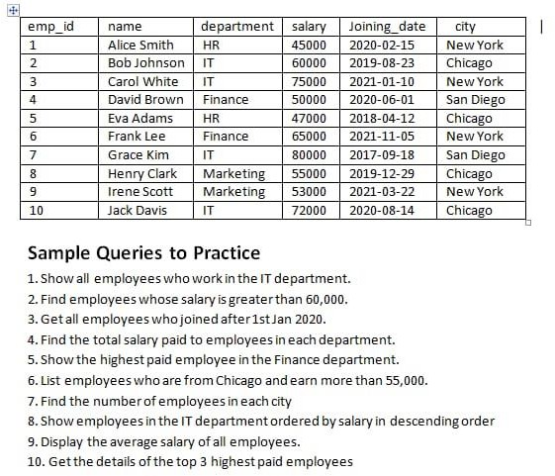

Create the employees Table.

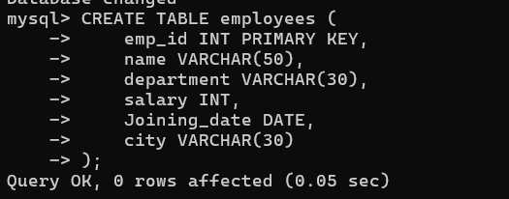

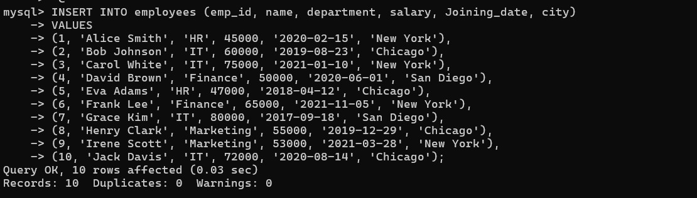Insert the values into employees Tables.

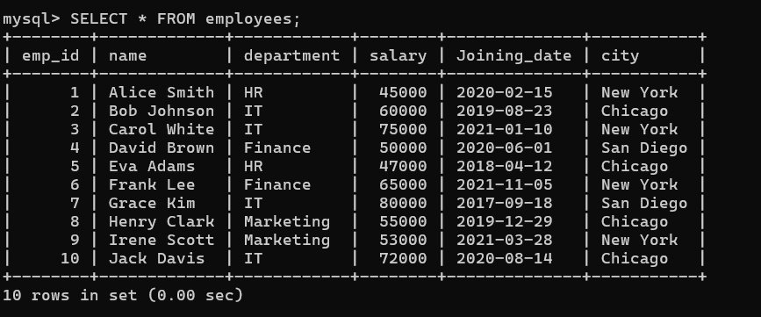Show all values in employees Table.

1. 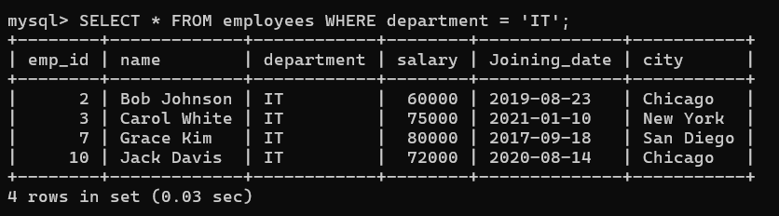**Show all employees who work in the IT department.**
2. 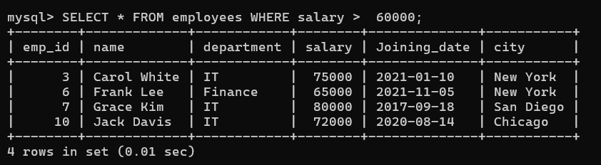**Find employees whose salary is greater than 60,000.**
3. 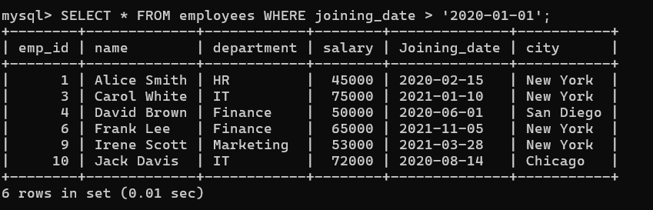**Get all employees who joined after 1st Jan 2020.**
4. 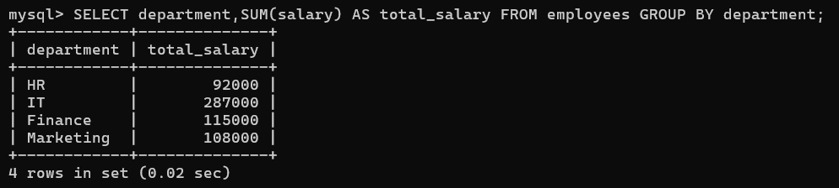**Find the total salary paid to employees in each department.**
5. 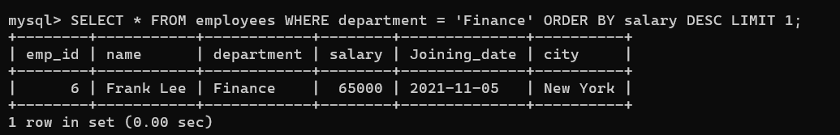**Show the highest paid employee in the Finance department.**
6. 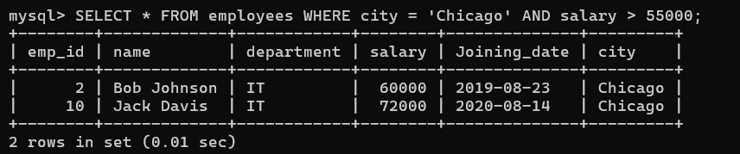**List employees who are from Chicago and earn more than 55,000.**
7. 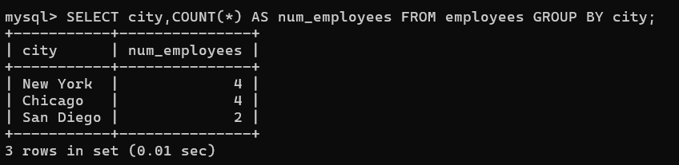**Find the number of employees in each city.**
8. 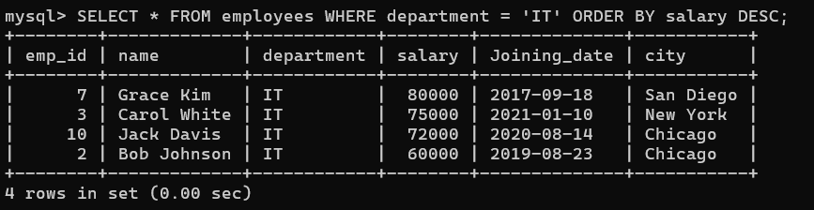**Show employees in the IT department ordered by salary in descending order.**
9. 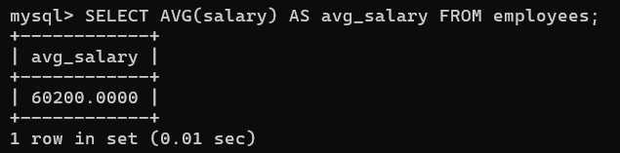**Display the average salary of all employees.**
10. 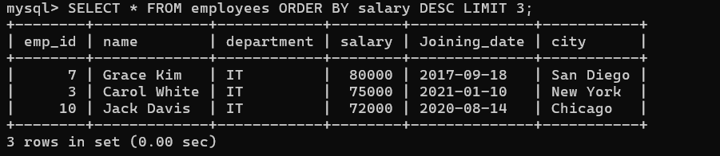**Get the details of the top 3 highest paid employees.**